Assignment 8

Brian Batinchok (A)
Ryon Riley (A)
Jesse Lambert (B)
Ian Vigrass (B)
Alex Lorenzo (A)

- Configure interface and ports for the router of LAN-A.
LAN-A
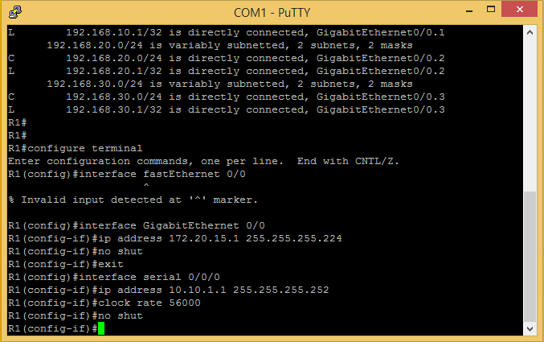
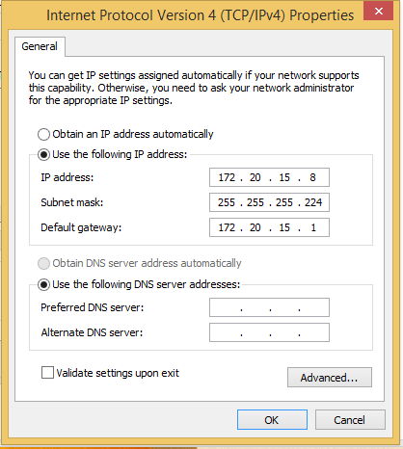
- Configure interface and ports for the router of LAN-B.
LAN-B:
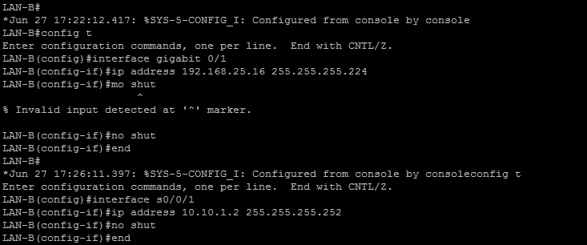

- Set Hostnames for the routers:
LAN-A:
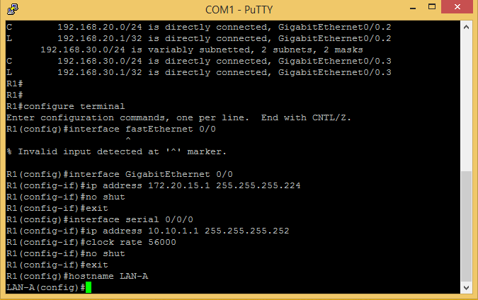

LAN-B:

- Show the ip interface brief responses:
LAN-A:
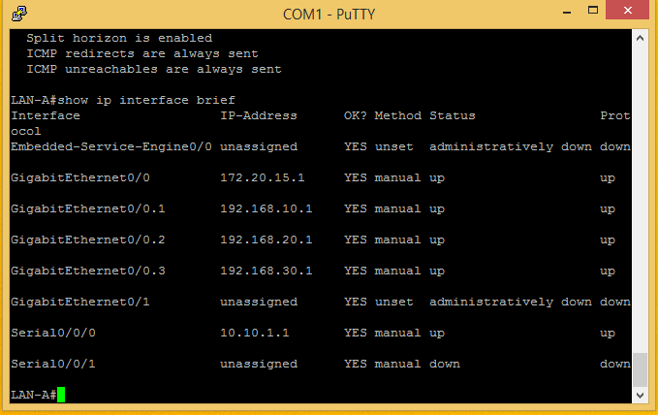

LAN-B:
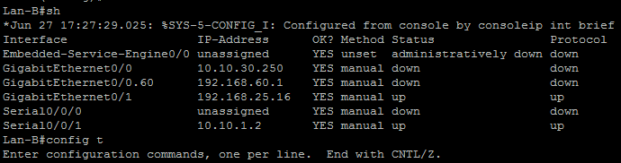

- Configure the OSPF routing protocol:
LAN-A: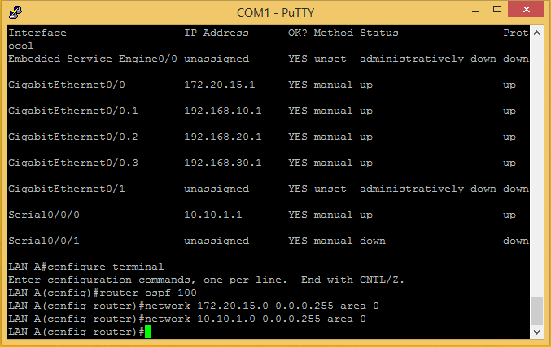

LAN-B: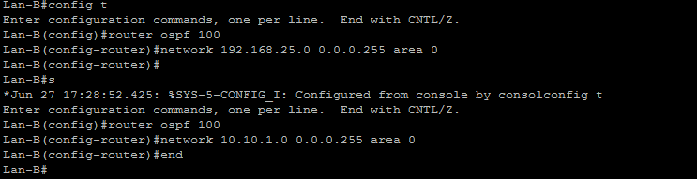

- Show ip route for the routers:
LAN-A:
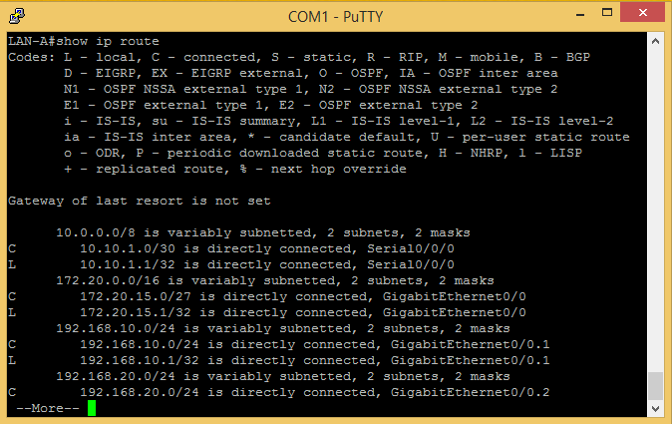

LAN-B:
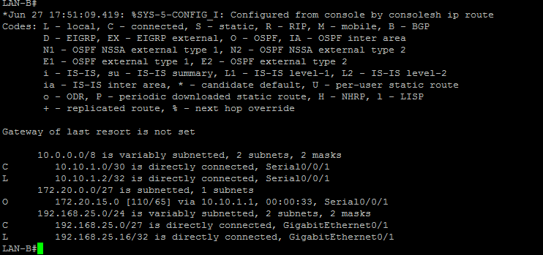

- Ping each other:
LAN-A:
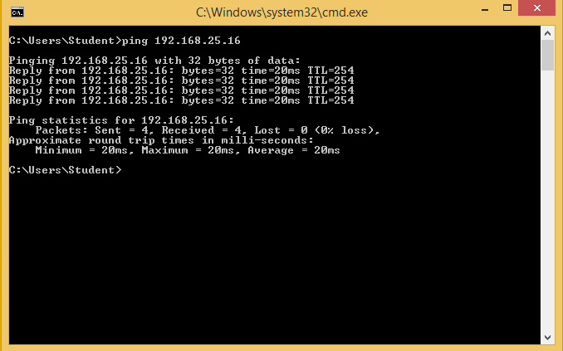
LAN-B: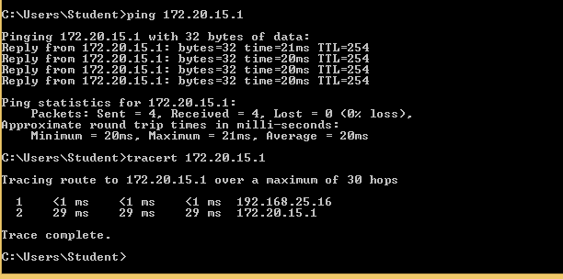
- Traceroute Each Connections:
LAN-A:

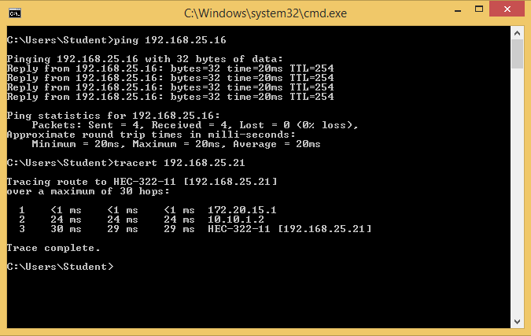

LAN-B:
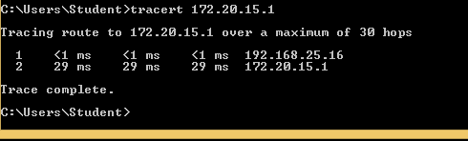

- Telnet Connection:
LAN A:
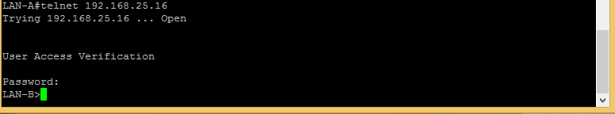
LAN B: enable secret ciscopress
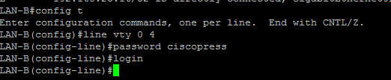

- Copy run start from LAN A and LAN B:
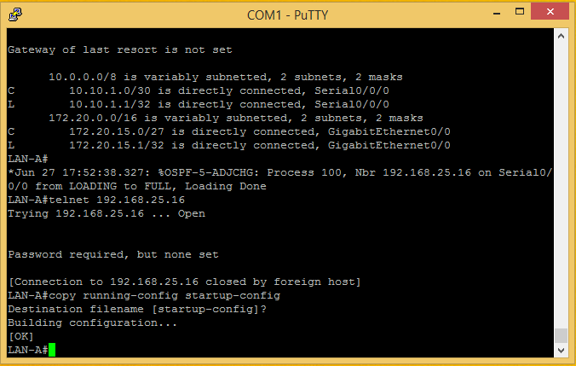
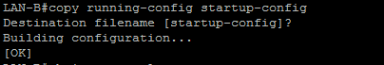

- Show ip protocols:

